**Ideamarket Bonding Curve**

**The Ideamarket Bonding Curve**

The Ideamarket contracts use a bonding curve to determine the price for buy and sell operations. The price depends on the existing supply of the corresponding IdeaToken when the operation is executed. The higher the existing supply the higher the price.

This is the shape of the bonding curve used by the Ideamarket contracts:

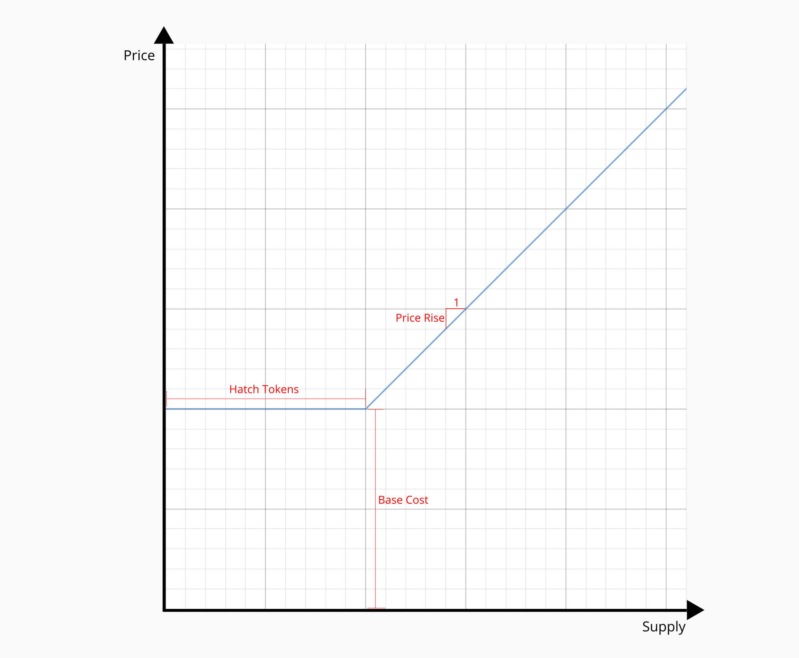

There are three parameters which can be set per market:

* Base Cost (*b*): The initial value at which the bonding curve starts
* Hatch Tokens (*h*): The amount of IdeaTokens for which the price stays fixed at Base Cost
* Price Rise (*r*): The rise in price per IdeaToken supply

**Price Calculation**

Let $S$ be the current supply and $P\left(x\right)$ be the price on the bonding curve for supply $x$*.*

Then the cost to buy $A$ IdeaTokens can be calculated as the integral from $P\left(S\right)$ to $P\left(S+A\right)$: $\int_{S}^{S+A}{P\left(x\right)} dx$ which is the area under the line in the chart between the two points $P\left(S\right)$ and $P\left(S+A\right)$.

Due to the hatch period $P\left(x\right)$ is a step function defined as:

$$P\left(x\right)=\left\{\begin{aligned} H\left(x\right) = b x≤h \\ O\left(x\right)=b+\left(x-h\right)⋅r x>h\end{aligned}\right.$$

For purchases entirely in the hatch period, i.e. $S+A ≤h$, the price calculation is straightforward as there is only a fixed price:

$$P\left(x\right)=H\left(x\right)=b$$

$$\int_{S}^{S+A}{H\left(x\right)} dx = A⋅b$$

To obtain the price we multiply the amount of IdeaTokens to be bought with the base cost.

For purchases entirely outside the hatch period, i.e. $S > h$, we use the following calculation:

$$P\left(x\right)=O\left(x\right)=b+\left(x-h\right)⋅r$$

$$\int_{S}^{S+A}{O\left(x\right)} dx=A ⋅\frac{O\left(S\right)+O\left(S+A\right)}{2}$$

To obtain the price we multiply the amount of IdeaTokens to be bought with the average price between $O\left(S\right)$ and $O\left(S+A\right)$.

For purchases which cross the hatch period border, i.e. $S < h < S+A$ we need to calculate the amount in the hatch period and the amount outside the hatch period separately:

$$\int_{S}^{h}{H\left(x\right)}dx+\int_{h}^{S+A}{O\left(x\right)}dx=\left(h-S\right)⋅b+\left(S+A-h\right)⋅\frac{O\left(h\right)+O\left(S+A\right)}{2}$$